

I Thought There’d Be More Flying Cars
A solo exhibition by Michelle Le Plastrier

A FREE exhibition by acclaimed multidisciplinary artist and Environmental Art Award winner Michelle Le Plastrier will premiere at The Webb Gallery, South Bank from August 30th to September 10th. I Thought There’d Be More Flying Cars will take visitors on a journey through an imagined future, aptly named 'The next 80’s'.

Le Plastrier employs retrofuturism, (a contemporary way of looking at the future with the anticipation of what science, technology, and design would look like), aesthetics to highlight the disparities between the futuristic visions of the 1980s and our present-day reality, while hypothesising potential trajectories for the future (2080).

Through a series of hand-built ceramics, all in her signature candy coloured style, the exhibition delves into the interconnectedness of progress and the regressive symptoms of technological advancements, such as diminished attention spans and the environmental impacts of overconsumption.

The multimedia works present the perspective of optimism and pessimism (or perhaps realism) through the story of these imagined futures. Visitors are encouraged to reflect on critical questions: Is this the future we envisioned? Are we progressing in a stable manner? Can we keep pace with rapid technological changes? The narrative invites contemplation on whether our current path inspires hope or demands a call to action for change.

About Michelle Le Plastrier:

Michelle teaches introductory ceramics across South-East Queensland. She has completed residencies, produced workshops and exhibited across Australia for businesses, galleries and councils such as Gold Coast Arts and Culture, Level Up Studio + Gallery, Pacific Fair, HOTA, Side Gallery and Honey Bones Gallery.

She recently won the Environmental Art Award at the Queensland Regional Art Awards and was a finalist in the 2022 North QLD Ceramic Awards at Perc Tucker Regional Gallery. Her recent body of work Dopamine Days is on exhibit at Home of the Arts on the Gold Coast until April 2024. Michelle graduated from a Bachelor of Visual Media from the Queensland College of Art. Michelle was an artist-in-residence through HOTA’s inaugural ArtKeeper program in 2021-22.

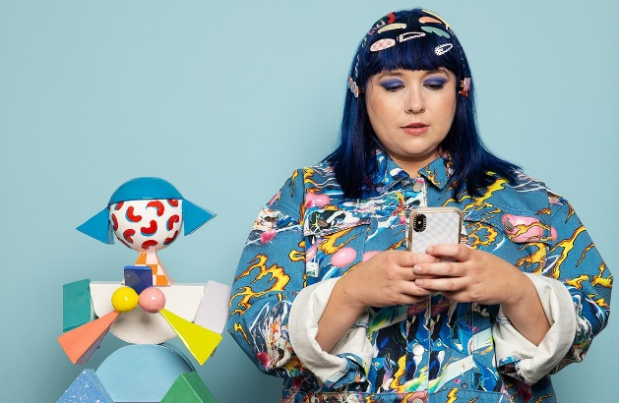
What: I Thought There’d Be More Flying Cars
When: 30th August to 10th September
(Tues to Sat 10am to 4pm)
Where: The Webb Gallery, Queensland College of Art,
226 Grey St, South Brisbane.
Cost: FREE

For further media information, images and interviews please contact:
Cinnamon Watson Publicity ~ 0432 219 643 ~ cinn@cinnamonwatsonpublicity.com.au

